Small Walk Behind Floor Sweeper Scrubber P12
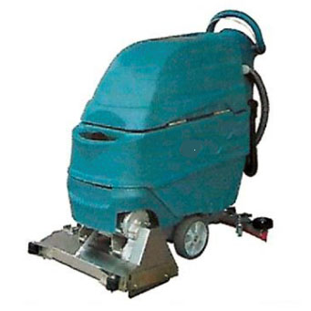
Product Introduction:
Small Walk Behind Floor Sweeper Scrubber P12 integrates scrubbing with sweeping function in one. The rolling brush system can collect small garbage such as bits of wood, light metal fragments, scraps of papers and etc into the garbage box to avoid blocking and damaging to the suction system. Compared with disc brush, the rolling brush has much better cleaning performance on rough floor.

Features
1. Simple operation panel, working speed can be adjusted according to working condition.
2. Drawer-type stainless steel garbage box,easy to load/unload and wash.
3. Roller brush can be replaced quickly without tool.
4. Special designed filling hole ensure easy opening and filling of fresh water.
5. Maintenance free battery kit.
6. Squeegee Isequipped with bracket wheel for betterstability in work.
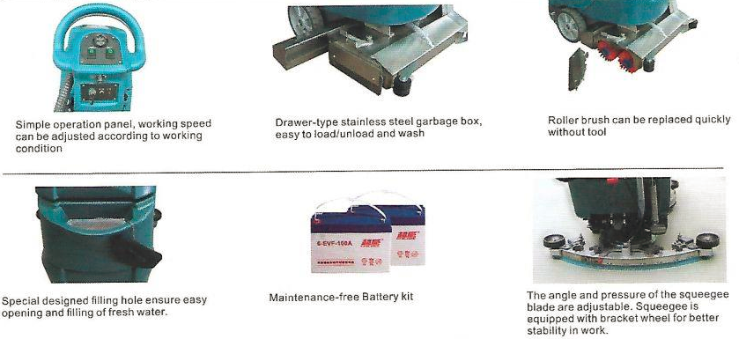
Product Parameter
Technical Data | Voltage | Cleaning Width | Suction Width | Area performance | Brush Motor | Suction Motor | Water Tank | Dimensions
Unit | V/AH | mm | mm | m²/h | W | W | L | cm
P12 | 24/120 | 530 | 770 | 2200 | 650 | 500 | 45/56 | 127*55*109

