Carpet Dry Machine PD400
Introduction
Carpet Dry Machine PD400 is a high performance carpet dryer to dry carpet quickly. Intelligent operation, simple and easy with wide application.
Technical Data
Model | Voltage/Frequency (V/Hz) | Power (W) | Vacuum Suction(Kpa) | Hot Air Flow(m3/min) | Hottest Air Temperature(℃)
PD400 | 220/50 | 1200±8% | ≥22 | 6 | 60

Noise  (db/m) | Power Cable Length(m) | Power Cable Tension (N/min) | Voltage Resistant Detection (mA) | Motor Life(h)
≤78 | 10±3% | ≤3 | 1 | 600
Features
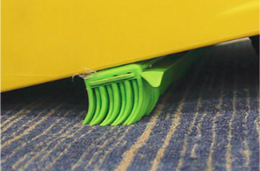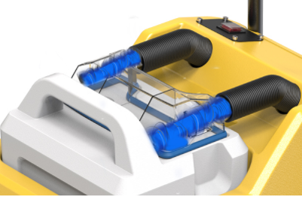
Comb hair treatment to form a smooth air duct. Large air volume inhalation, residual detergent
First of all, the clean carpet fluff is combed and moisture. Small incision and high pressure
through the brush of the book, and the trend is scraping can more effectively peel off the deep
unified and the effective air duct is formed. moisture of the carpet and pile up and collect it
in front of the suction.
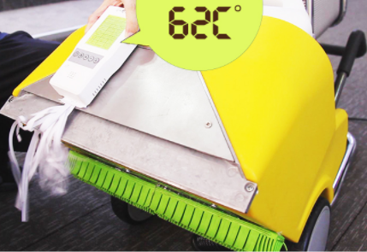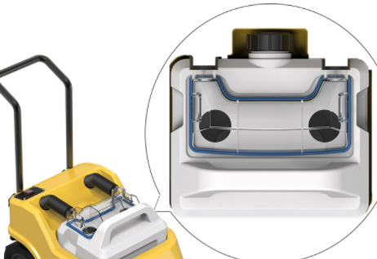
Heating and drying, evaporation of surface Stain observation window
moisture. Using the heat generated by the Know carpet humidity and contamination.
high-speed impeller, through the front section,
the suction mouth of the carpet drying.
Application
Suitable for office, restaurant, corridor, etc..
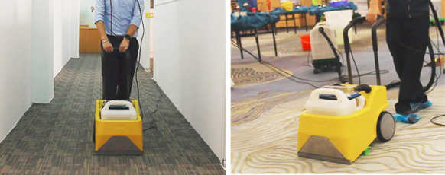
For passageway carpet For dining room carpet

