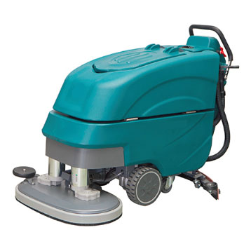
Dual Brush Walk Behind Scrubber PA860/660
Product Introduction:
With dual brushes PA860 is an easy-handling machine for large and medium area with low operating cost. This machine is self-propelled which can save cleaning workload greatly. The dual brushes enhance the cleaning efficiency and save the cost. Equipped with powerful electronic controlling system, scrubbing and drying functions can be operated easily. Due to the polyester water tank and rear control panel, the machine has lower sound level. Moving forward, backward and the brushes can be controlled by the operating handle.

Features
- Maintenance free battery is durable and does not need manual maintenance
2. Easy-handling machine for large and medium area with low operating cost.
3. It is self-propelled which can save cleaning workload greatly.
4. Equipped with powerful electronic controlling system, scrubbing and drying functions can be operated easily.
5. Lower sound level due to polyester water tank and rear control panel.
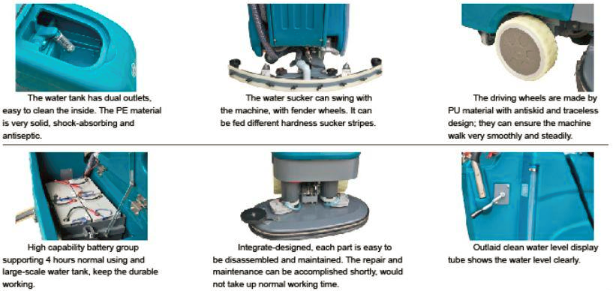

Performance Parameters
Technical Data | Voltage | Cleaning Width | Suction Width | Area performance | Brush Motor | Suction Motor | Water Tank | Dimensions | Weight
Unit | V/AH | mm | mm | m²/h | W | W | L | cm | kg
PA860 | 24/200 | 860 | 1100 | 4200 | 560*2 | 500 | 95/105 | 150*95*124 | 302
PA660 | 24/200 | 660 | 1080 | 3600 | 560*2 | 500 | 95/105 | 143*76*18 | 295

