Small Walk Behind Floor Scrubber PA530
product Introduce：
P530 automatic floor washing machine is a battery type floor washing machine with flexible operation, which is very suitable for the maintenance and cleaning of small and medium-sized sites. The product is simple in design, simple in operation, stable in quality, with professional circulating battery, which can provide lasting power and complete various cleaning tasks with high requirements.

Product advantages：
- Imported high power motor, good performance and long service life
- Control panel double switch design, extremely simple and comfortable to use
- Cast iron technology is adopted for water absorption pickling, which is durable and easy to maintain.
- The water tank adopts polyethylene roll molding process, with corrosion resistance and impact resistance.
- Built in sewage filtration device, water full shutdown, easy to use.
- The control system adopts solid and durable relay system with long service life.

Product characteristics:
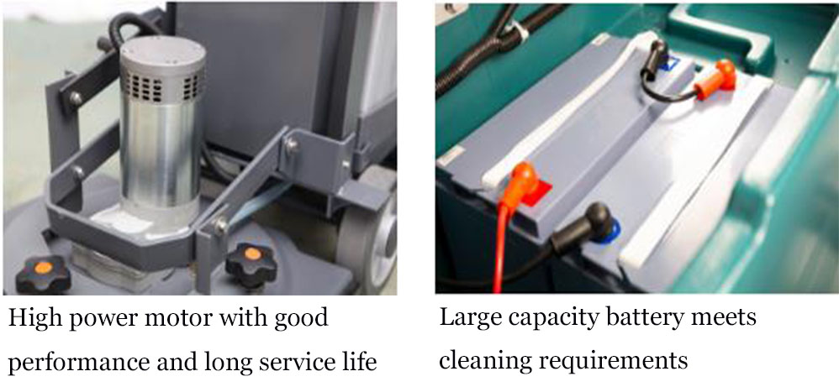
Technical Data | Voltage | Cleaning Width | Suction Width | Area performance | Brush Motor | Suction Motor | Water Tank | Dimensions | Weight
Unit | V/AH | mm | mm | m²/h | W | W | L | cm | kg
PA530B | 24/120 | 530 | 770 | 2100 | 650 | 500 | 50/55 | 116*54*106 | 189
PA530E | 220 | 530 | 770 | 2100 | 1100 | 500 | 50/55 | 116*54*106 | 175

